### AY2017 Semester 2

|  |  |  |  |
| --- | --- | --- | --- |
| Name |  | | |
| Student ID |  | | |
| Assessment Venue |  | Seat Number |  |

**E331 ESE**



E331 Supply Chain Management

**AY2017 Semester 2 End-Semester Examination (ESE)**

|  |  |
| --- | --- |
| **Instructions to student:** | |
| 1) | Do not turn over this question paper until you are instructed to do so by the invigilator. |
| 2) | Write your name, student ID, assessment venue and seat number in the table provided at the top of each page. |
| 3) | For this question paper, there are **19** pages (including this cover page). |
| 4) | For this assessment, you are allowed to:   * Refer to materials stored in your laptop. * Have only one set of hardcopy notes in bound form, and no larger than A4 size * Have a blank piece of paper for rough working purpose. (Note that the sheet of rough working paper will not be accepted for submission at the end of the assessment.) |
| 5) | For this assessment, you are **NOT** allowed to:   * Refer to written materials including textbooks and hardcopy notes in loose form or larger than A4 size. * Share any material, such as calculators, with another student. * Communicate with any person other than the invigilator. * Use any communication devices such as handphone or smart watches while at the assessment venue. |
| 6) | All rules and regulations pertaining to summative assessments and academic integrity stated in the Student Handbook shall also apply. |

|  |  |  |
| --- | --- | --- |
| ***This segment is to be used by staff grader(s) only.*** | | |
| **Question Number** | **Marks Awarded** | **Max Marks** |
| **1** |  | **5** |
| **2** |  | **20** |
| **3** |  | **19** |
| **4** |  | **17** |
| **5** |  | **17** |
| **6** |  | **22** |
|  |  |  |
|  |  |  |
|  |  |  |
|  |  |  |
|  |  |  |
|  |  |  |
|  |  |  |
|  |  |  |
|  |  |  |
|  |  |  |
| **Total** |  | **100** |

|  |  |  |
| --- | --- | --- |
| ***This segment is to be used by the invigilator only and for ‘online’ and ‘online and paper’ mode assessments only*** | | |
| Please tick the box below if the student has done part of the assessment online: | Invigilator’s Name: | Invigilator’s Signature: |
| Partially done online |  |  |

## Page 1 of 19

**Question 1 [5 Marks]**

### Multiple Choice Question (only one answer is required and write it in the box provided)

1. Through the Beer Game, players can experience typical problems of traditional supply chains. Which of the following is **NOT** one of the problems? (1 mark)
   1. Higher inventory costs in the whole supply chain
   2. Poor customer satisfaction and lost sales
   3. Insufficient or excess capacity for warehouse or production
   4. Promotions and Price fluctuation
2. Which of the followings may decrease as the number of facilities increase in a distribution network? (1 mark)
   1. Facility and handling costs
   2. Inventory costs
   3. Inbound transportation costs
   4. Outbound transportation costs
3. Which of the followings is **NOT** one of the benefits of applying milk run for delivery?

(1 mark)

* 1. Save the traveling distance and time
  2. Reduce the number of trucks being used
  3. Avoid full truck load to reduce transportation cost
  4. Increase return on supply chain investment

1. Which of the following statements regarding SCOR metrics is **TRUE**? (1 mark)
   1. Level 1 SCOR metrics measure a part of the supply chain
   2. Every level 1 SCOR metric corresponds to one level 1 SCOR process
   3. To calculate the level 2 metrics, just add up all its immediate level 3 metrics
   4. Level 3 SCOR metrics can be used to diagnose where problems originate
2. Which of the following statements regarding greening a warehouse is **NOT CORRECT?**

(1 mark)

* 1. Implement a solar power system at the rooftop of the building
  2. Use Mobile Pallet Racking for efficient use of warehouse footprint
  3. Use Stretch Wrap Machine instead of manual wrapping to reduce usage of plastic film
  4. Switch on engines while loading/unloading at loading bays

# Question 2 [20 Marks]

Genius Toys is a famous designer and manufacturer who makes all kinds of premium toys for kids. Its supply chain is shown in Figure 2a. The current supply chain design is Build-To- Stock (BTS). All the finished products are stocked at retailers.

**Suppliers**



**Factories**



**Distribution Centers with Assembly Capability**

**Retailers**

Figure 2a Genius Toys Supply Chain

1. Due to the inaccurate demand forecasting, retailers always have excessive inventory at their places. Genius Toys considers using Build-to-Order (BTO) which does not need to forecast demand for every product at all.
   1. In terms of push-pull strategy, where is the push-pull boundary for BTO? (1 mark)
   2. It is found that the sales volume drops drastically after implementing BTO. Give **ONE**
      1. possible reason to explain this. (2 marks)
2. The products from Genius Toys have common parts with many variations in terms of different colours and decorations. Answer the following questions.
   1. Other than BTO, suggest **ONE (1)** supply chain design which can also help Genius Toys solve the issue of holding too much inventory (1 mark)
   2. Where is the push-pull boundary for your suggested design? (1 mark)
   3. Explain how it can reduce the overall inventory level for the entire supply chain.

(2 marks)

1. As a business for kids, Genius Toys decided to go green for its supply chain to show its concerns for the environment and create good social impacts. Name **THREE (3)** challenges to implement the green supply chain. (3 marks)
2. In green perspective, the supply chain has the following phases shown in Figure 2b.



*Phase 1:* **Inbound Logistics**

*Phase 2:*

**Production**



*Phase 3:* **Outbound Logistics**



*Phase 4:* **Reverse Logistics**

Figure 2b Green Supply Chain Phases

One of the green initiatives that Genius Toys has taken is using corn, a kind of natural crop to make toys.

* 1. Refer to Figure 2b, which phase should this initiative be taken at? (2 marks)
  2. In order to better work on environmental initiatives with its vendors of supplying corn, recommend **TWO (2)** green initiatives that Genius Toys can consider. (2 marks)

1. Genius Toys’ headquarter is in US but it has a few manufacturing plants in Asia. One factory is in Thailand supplying its global market due to its low operational cost. As the China market is growing very fast, it is going to set up one factory in southern China to save the high logistics cost and other tariff barriers set by China government.
   1. What are the strategic roles that the Thailand plant and China plant play for Genius Toys respectively? (2 marks)
   2. Before the Thailand plant was built, the market survey showed the demand is much lower than the expected number in the near and long term. However, the management still decided to build a high capacity plant which can produce various product series. In terms of risk mitigation, give **TWO (2)** possible reasons on this over-capacity decision. (4 marks)

# Question 3 [19 Marks]

Mother-Likes is a famous US brand selling all kind of products for babies, kids and mums. It sets up a branch office and a small warehouse in Singapore to support the market of South East Asia.

1. The Singapore warehouse serves as the intermediate place to consolidate all the products from the factories at China, US and Europe and send the products to end customers in Singapore, Malaysia and Indonesia via their partner logistics provider, UPS.
   1. What kind of distribution network design Mother-Likes is adopting right now? (1 mark)
   2. In terms of demand pattern, what kind of items are the most suitable for this network design? (1 mark)
2. As their business is growing, Mother-Likes thinks it better to set up their own shops or partner with local shops to reach more customers. Through this way, it can even save the delivery costs from the warehouse to customers and customers can come to the shops to buy.
   1. In this case, what is the new network design that Mother-Likes would like to shift to?

(1 mark)

* 1. Give **TWO (2)** disadvantages of this kind of network design. (2 marks)

1. The management of Mother-Likes decided to differentiate the distribution network design for the low demand, high variety and premium price products. Refer to the Figure 3a, recommend **ONE (1)** appropriate distribution network for this kind of products. Show your quantitative analysis to support your recommendation. (4 marks)

|  |  |  |  |  |  |  |
| --- | --- | --- | --- | --- | --- | --- |
|  | **A** | **B** | **C** | **D** | **E** | **F** |
|  | **Retail Storage with Customer Pickup** | **Manufacturer Storage with Direct Shipping** | **Manufacturer Storage with In- Transit Merge** | **Distributor Storage with Package Carrier Delivery** | **Distributor Storage with Last Mile Delivery** | **Manufacturer**  **/Distributer Storage with Customer Pickup** |
| High Demand Product | 2 | -2 | -1 | 0 | 1 | -1 |
| Medium Demand Product | 1 | -1 | 0 | 1 | 0 | 0 |
| Low Demand Product | -1 | 1 | 0 | 1 | -1 | 1 |
| Very Low Demand Product | -2 | 2 | 1 | 0 | -2 | 1 |
| Many Product Sources | 1 | -1 | -1 | 2 | 1 | 0 |
| High Product Value | -1 | 2 | 1 | 1 | 0 | -2 |
| Quick Desired Response | 2 | -2 | -2 | -1 | 1 | -2 |
| High Product Variety | -1 | 2 | 0 | 1 | 0 | 2 |
| Low Customer Effort | -2 | 1 | 2 | 2 | 2 | -1 |

Figure 3a Product Characteristics & Customer Preferences (the larger the better)

1. In general situations, in terms of the variety of products, sequence the 3 types of Mother- Likes’ facilities, Factories at China, US and Europe, Warehouse in Singapore, Partner Retailers on the horizontal axis in Figure 3b by matching them to X, Y and Z respectively.

(3 marks)

Variety of Products

**X**

**Y**

**Z**

Figure 3b Sequence of 3 Types of Facilities of Mother-Likes

1. As Mother-Likes’ business expands very fast, the company considers to set up another warehouse in one of the other South East Asia country. Some market research has done to understand the demand correlation between demand in Singapore and the other countries shown in Figure 3c. Which country is the most appropriate to open the other warehouse? Explain your answer. (3 marks)

Demand in Other Countries

Vietnam

Philippines

Indonesia

Malaysia

Demand in Singapore

Figure 3c Demand Correlation between Singapore and other countries

1. Recently, some customer complaint about the quality of one type of baby food processor sold from Mother-Likes warehouse. According to the policy, customers can return their product within 14 days if any defects are found.
   1. According to SCOR Model, what is the standard **level 2** process code for the process of accepting the defective products? (1 mark)
   2. Actually all the electronic products had been tested and then sent. Give **TWO (2)**

possible **level 3** processes would Mother-Likes further investigate on this problem?

(3 marks)

# Question 4 [17 Marks]

Dr.Hoo Pte Ltd is a distributor importing and selling rice, flour and other grocery products in Singapore.

1. When the company just started, it was not using Milk Run to deliver their orders.
   1. Among the four diagrams shown in Figure 4a, which one best represents the company’s past situation without Milk Run? (2 marks)
   2. It was found that the transportation cost was much higher than using Milk Run, Give

**TWO (2)** reasons on how the way you chose in question i) would incur higher cost.

(2 marks)

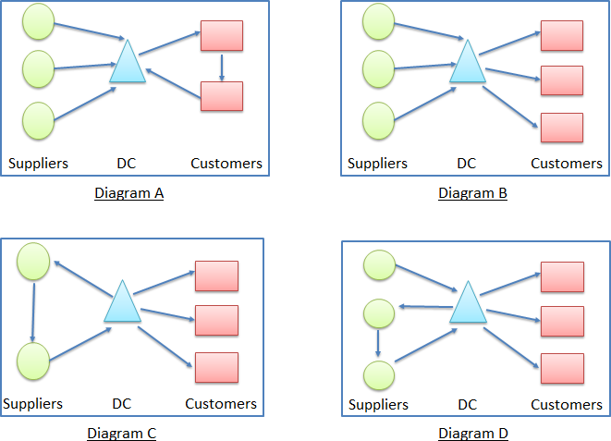

Figure 4a Delivery without Milk Run

1. Later on Dr. Hoo decided to implement milk run for delivery, customer’s order size is given in Table 4a. The truck capacity is 200 standard cartons, how many trucks are required to deliver all the orders at the same time? (2 marks)

Table 4a Customer Order Size

|  |  |
| --- | --- |
|  | **Order size (standard carton)** |
| **Customer 1 (C1)** | **70** |
| **Customer 2 (C2)** | **60** |
| **Customer 3 (C3)** | **80** |
| **Customer 4 (C4)** | **60** |
| **Customer 5 (C5)** | **90** |

1. The distance matrix from its warehouse to all the customers and between all customers are given in Table 4b.

Table 4b Distance Matrix (WH – Dr. Hoo’s warehouse)

|  |  |  |  |  |  |  |
| --- | --- | --- | --- | --- | --- | --- |
| **Distance Matrix (in miles)** | | | | | | |
|  | **WH** | **C1** | **C2** | **C3** | **C4** | **C5** |
| **WH** | **0** |  |  |  |  |  |
| **C1** | **17** | **0** |  |  |  |  |
| **C2** | **13** | **12** | **0** |  |  |  |
| **C3** | **17** | **12** | **12** | **0** |  |  |
| **C4** | **15** | **8** | **9** | **15** | **0** |  |
| **C5** | **10** | **19** | **18** | **14** | **16** | **0** |

* 1. In order to use the Savings Matrix Method, Dr.Hoo has to identify the distance savings matrix. Calculate the value for the cell **A** in Table 4c to complete the distance savings matrix. Show your workings clearly. (2 marks)

Table 4c Distance Savings Matrix

|  |  |  |  |  |  |
| --- | --- | --- | --- | --- | --- |
| **Distance Savings Matrix (in miles)** | | | | | |
|  | **C1** | **C2** | **C3** | **C4** | **C5** |
| **C1** | **0** |  |  |  |  |
| **C2** | **18** | **0** |  |  |  |
| **C3** | **22** | **18** | **0** |  |  |
| **C4** | **24** | **A** | **17** | **0** |  |
| **C5** | **8** | **5** | **13** | **9** | **0** |

* 1. Identify the best saving routes for all the trucks. Calculate the total loadings for each route, assuming one truck takes one route. (5 marks)
  2. Starting at the warehouse, use the Nearest Neighbour method to sequence the customers in the route with the most number of stops that you identified in the question iii). Calculate the total traveling distance for the route. (4 marks)

# Question 5 [17 Marks]

Flying-Tech is a manufacturer and distributor of all type of drones in South East Asia. At the end of every financial year, the accountants will provide the income statements and balance sheets for the management to review. A set of simplified financial reports are given in Table 5a and Table 5b below. Assume one year has 365 days.

Table 5a Simplified Income Statement (all amounts in Million $)

|  |  |  |
| --- | --- | --- |
|  | **FY2016** | **FY2017** |
| Revenue (Net Sales) | 679.69 | 706.29 |
| Cost of goods sold (COGS) | 317.5 | 308.04 |
| Gross profit | 362.19 | 398.25 |
| Total operating expenses | 154.23 | 130.78 |
| Operating Income | **A** | 267.47 |
| Total Non-operating income (expense) | 39.43 | -2.85 |
| Net Income | 247.39 | 264.62 |

Table 5b Simplified Balanced Sheet (all amounts in Million $)

|  |  |  |
| --- | --- | --- |
|  | FY2016 | FY2017 |
| Total cash | 1,296.83 | 1,476.29 |
| Total Accounts Receivables | 431.94 | 478.72 |
| Total Inventories | 503.18 | 466.48 |
| **Total current assets** | **2,231.95** | **2,421.49** |
| **Total non-current assets** | **2,156.52** | **2,247.87** |
| Accounts payable | 158.67 | 144.88 |
| Other Current liabilities | 735.99 | 978.6 |
| **Total current liabilities** | **894.66** | **1,123.48** |
| **Total non-current liabilities** | **B** | **309.47** |
| Total Stockholders' Equity | 3,234.68 | 3,236.41 |

1. Refer to Table 5a and 5b, find the value for cell **A** in Table 5a and cell **B** in Table 5b respectively. Show your workings clearly and round up your answer to 2 decimal places.

(4 marks)

1. Refer to Table 5a and 5b, find the values for cell C and D in the Table 5c. Show your working clearly and round up your answer to the nearest integer. (5 marks)

Table 5c Cash to Cash Cycle Time

|  |  |  |  |  |
| --- | --- | --- | --- | --- |
|  | **Inventory Days of Supply** | **Accounts Receivable**  **(A/R) Days** | **Accounts Payable (A/P)**  **Days** | **C2C days(Cash to cash cycle**  **time)** |
| **FY2017** | 574 | 235 |  |  |

1. The management has some feedback on the C2C days as follows.
   1. Inventory days of supply is too long. Suggest **TWO (2)** ways to shorten the inventory days of supply. (2 marks)
   2. If the C2C days is a negative number, is this a good sign? What does a negative number mean? (2 marks)
2. Besides the financial performance, the company has done an overall performance review and benchmarking with other companies in the same industry for FY2017. The benchmarking SCORcard is shown in Table 5d.

Table 5d Benchmarking Analysis for Flying - Tech

|  |  |  |  |  |  |
| --- | --- | --- | --- | --- | --- |
|  | | | **Performance Versus Competitive Population** | | |
|  | | Actual | Parity | Advantage | Superior |
| **Supply Chain Reliability** | **Perfect Order Fulfilment (%)** | 94% | 85% | 90% | 95% |
| **Responsiveness** | **Order Fulfilment Cycle Time (days)** | 4 | 7 | 5 | 3 |
| **Flexibility** | **Upside Supply Chain Flexibility** | 15 | 14 | 10 | 7 |
| **Cost** | **Total Supply Chain Management Cost/Total**  **Operational Costs** | 11% | 13% | 8% | 3% |
| **Assets** | **Return on Working Capital** | 7.5% | 6% | 10% | 15% |

* 1. Among the 5 performance attributes, which one do you think the company has performed the worst? (2 marks)
  2. If the Return on Working Capital could be improved to the superior level, assuming no changes to the balance sheet, how much more operating income should be generated additionally in FY2017? No working is required. (2 marks)

# Question 6 [22 Marks]

*The following questions are related to SAP Sales and Distribution (SD) module.*

GoBike is a US based company who manufactures and distributes various types of bikes to local retailers, and the company also sells its bikes directly via their online website. All sales operations are centralized at its sales office located in New York.

1. Which organization unit is the highest level in SAP SD module and compulsory to have? What role does it play in SAP SD module? (2 marks)
2. What are the **TWO (2)** necessary checks that should be carried out when processing a sales order in SAP system? (2 marks)
3. Recently GoBike received a high value purchase order from UniverseBike who retails the bikes in east America. What should be done during sales order creation if GoBike would like to offer 5% discount for this sales order? Explain.

(2 marks)

1. Based on Figure 6a below, answer the following questions:
   1. What is the sales order number? (1 mark)
   2. What is the sales price per unit for this bike model? (1 mark)
   3. Which customer is this sales order for? (1 mark)
   4. What is the delivery order number? (1 mark)
   5. What is the picking quantity? (1 mark)
   6. Has the order been shipped out? (1 mark)

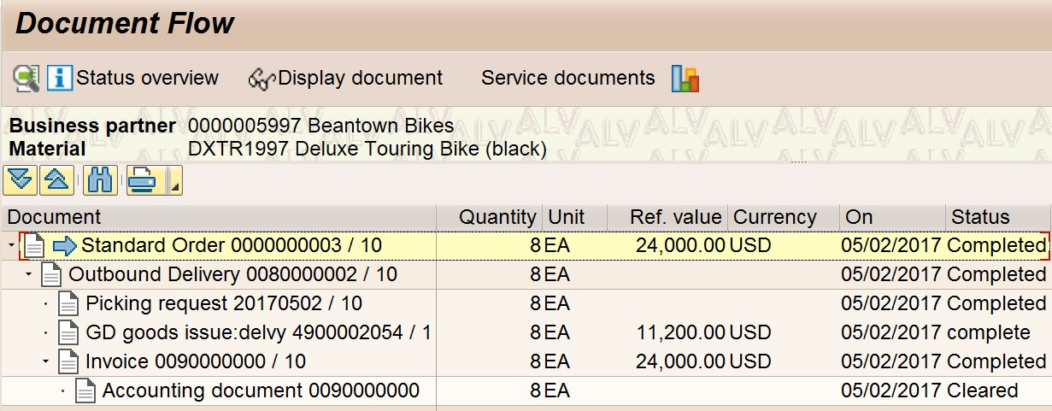

Figure 6a Document Flow

*The following questions are related to SAP Materials Management (MM) module.*

1. The engineering department of GoBike just fine tuned the design of one of its bikes by adding two small component parts. This modification requires the purchase of the two new component parts and identification of new vendors.

Which of the followings represents a typical order of steps performed in the purchasing process of SAP MM module? (2 marks)

1. Create purchase order --> create purchase requisition --> perform goods receipt --> Invoicing
2. Create purchase requisition --> create purchase order --> perform goods receipt --> Invoicing
3. Create purchase order --> perform goods receipt --> Invoicing --> create

purchase requisition

1. Perform goods receipt --> create purchase requisition --> create purchase order --> Invoicing
2. Which **TWO (2)** Master Data should be created in SAP system due to the modification of the design for the bike? (2 marks)
3. Similar to the centralized sales operations, the purchasing department of GoBike handles the purchasing for all the factories in America. How many purchasing organizations are required for SAP MM module in such case? (2 marks)
4. Name **TWO (2)** types of Purchase Orders that could be created in SAP system?

(2 marks)

1. What is the MM specific organizational unit that represents a buyer in SAP system? Describe **ONE (1)** role that it plays. (2 marks)

### --------------------- END OF PAPER ---------------------